

Submitted By:
Ali Zaman – CYS (A)-2026
Assignment:
LAB-1
Submitted To:
Sir. Mujtaba Kamal
For the Fulfillment Of:
Programming Fundamentals
Department Of Computer
Engineering
University Of Engineering And Technology, Lahore.
Task No.1:
Print your information.
Solution:
# Task 1:Print Your Information
print("Name:Ali Zaman")
print("Department: Computer Engineering")
print("University: UET Lahore")

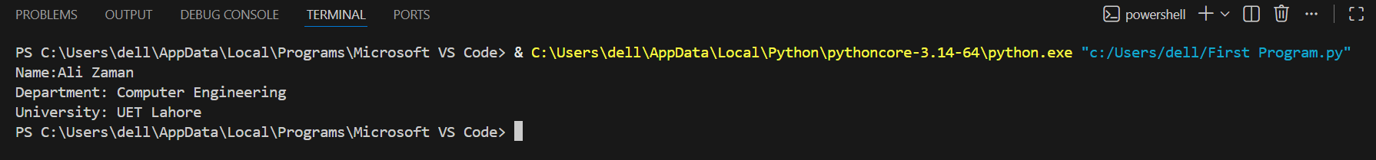
Output:

Task No.2:
Print information using sep and end.
Solution:
# Task 2:Ising sep and end
print("UET","Lahore","Computer","Engineering",sep="-")

Output:
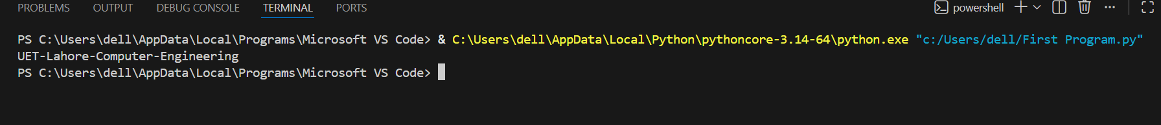

Task No.3:
Format Output.
Solution:
#Task 3: Format Output
#Name: Ali
#Age: 20
#City: Chishtian
print("Name: Ali\nAge: 20\nCity: Chishtian")

Output:
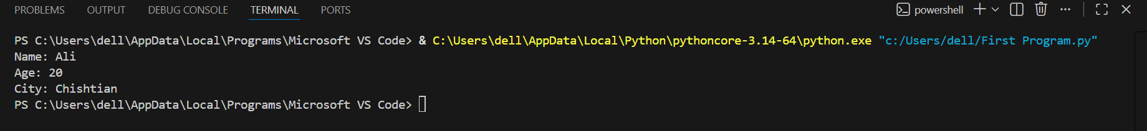
Task No.4:
Take name and age as input.
Solution:
name=input("Enter Your Name: ")
age=int(input("Enter Your Age: "))
print("Name: ",name)
print("Age: ",age)

Output:
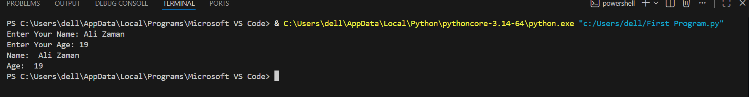

Task no.5:
Identify data types.
Solution:
x = 10
y = 3.14
z = True
name = "UET"
print(x)
print(y)
print(z)

print(type(x))
print(type(y))
print(type(z))
print(type(name))

print(len(name))

Output:
